Greetings Beauty From Ashes Ranch friends and family,
Happy August!
I always love this time of year. Monsoons are starting to bring some much-needed relief to the oppressive heat, schools are starting back up, things are turning green again. Change seems to be all around. Beauty From Ashes Ranch continues to grow and change as well.
I want to take a moment to inform everyone of some recent changes and what to expect in the near future:
Property Search:
The leadership team at BFAR has been on an absolute mission to find our first location and become operational as soon as practical. We have put our full trust in God and his guidance on where and when we will open our first operational ranch site. While we are not yet able to announce a completed deal and therefore our first location, I can share that we have a couple of very exciting potential opportunities that we are vetting at this time. I will send out updates as soon as we reach a concrete deal and have a firm path. I ask for continued prayers for God to open the doors that need to be open.
Volunteer opportunity:
We are seeking volunteers to help us draft policies and procedures. If you have that talent and are interested, please contact me at john@beautyfromashesranch.org
General:
In our continued effort to grow into a world class non-profit organization we have been intentional in our quest for accreditation through numerous non-profit tracking organizations. I am very excited to share that we have officially received our Gold Seal of Transparency from GuideStar/Candid! We remain absolutely committed to being good stewards of our generous donors funding and are voluntarily enrolling in these types of transparency and accreditation programs. 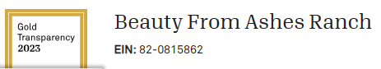

We will be changing our donor management systems, consolidating multiple operating systems into one easy to manage system called Flipcause. The transition will be transparent to you all and all functionality of our current website and systems will remain. You may start to see some minor changes in the website design in the coming months.

I want to thank Steve Gamble of Sonoita Fence for his amazing work and generosity donating the labor and talent needed for our new metal office signs.
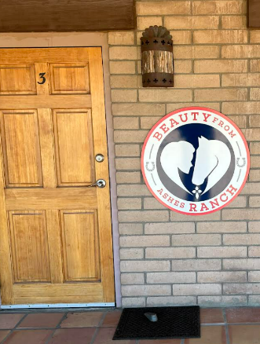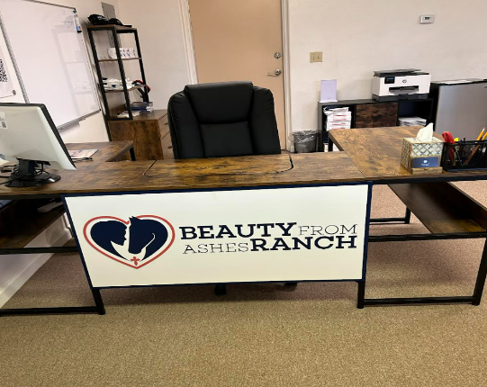

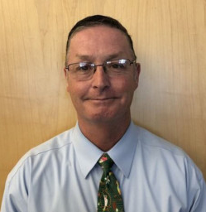
Farewell Mickey!! Mickey Petersen has elected to not seek another term as board member at BFAR for personal reasons. While Mickey continues to support BFAR and our mission, his last official meeting was in July. Mickey’s leadership has been instrumental in the continued growth and success of Beauty From Ashes Ranch and will certainly be missed. Please join us in thanking Mickey for his dedication and true heart for helping those in need. We ask for prayers for wisdom and guidance as BFAR searches for a replacement on the board of directors.
Thank you, Mickey!

Thank you all for your continued support and dedication to Beauty From Ashes Ranch. We appreciate each and every one of you more than we can possibly articulate.
Stay tuned for more and exciting updates!
God Bless you all!
John George
Executive Director
Beauty From Ashes Ranch
john@beautyfromashesranch.org
info@beautyfromashesranch.org

