Greetings Beauty From Ashes Ranch friends and family,
Happy September!
Hoping everyone had an enjoyable Labor Day weekend.
The Beauty From Ashes Ranch leadership team is continuing to grow and I could not be happier to announce that at our regularly scheduled Board of Directors meeting in August, the board voted to add Cindy Mechtel to serve on the board as Board President! Cindy is a local law enforcement hero who has a deep passion for helping those in need.
Please join me in welcoming Cindy to the Beauty From Ashes Ranch Board of Directors!
Please see Cindy’s Bio below:
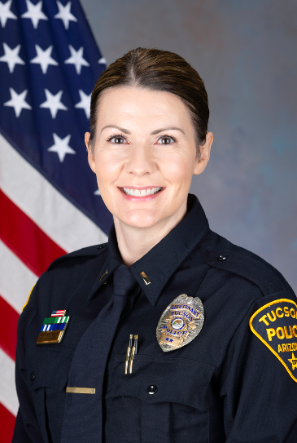
Cindy Mechtel is from Alaska and moved to Tucson, Arizona at age 14, where she attended high school at Canyon Del Oro High School. She has an AAS in Law Enforcement and a BS in Justice Studies. Cindy has a passion for serving others and has been involved in volunteer work for decades. She has served on various boards to include the Erik Hite Foundation, Southern Arizona Women of Law Enforcement and Hearts of Gold. She is currently the Tucson Police Department Liaison for Hearts of Gold.
Cindy is employed by the Tucson Police Department, where she has worked since being hired as a Crime Scene Specialist in 2000. In 2004, Cindy became a commissioned police officer and went on to promote to Detective, Sergeant, and to her current rank of Lieutenant. She spent 5 years working in child crimes and found that work to be the most impactful and meaningful to her. During that time, she served as a volunteer for the Special Victims Investigators of Tucson, raising funds to support the Children’s Advocacy Center of Southern Arizona in Tucson.
Cindy is married with a son, daughter-in-law, two grandchildren, and a Standard Poodle. She is dedicated to serving the Tucson community and has a heart for helping children and victims of sexual trauma. She is always looking for new ways to be of service and is excited to further the mission of Beauty From Ashes Ranch.
Welcome Cindy and thank you for your dedication to our mission and your service!
Volunteer opportunity:
I want to thank all those that volunteered to help proof and/or write our policies and procedures. We are kicking off that process next week. I will continue to provide updates via these newsletters and our website on additional volunteer opportunities.
General:
Coming soon to our website will be a detailed view of our Calendar of Community Engagements. It will have a list of upcoming events that representatives from BFAR will be speaking at, participating in or hosting. We will be providing details on dates, times, and locations of the events and will provide specifics on how to join and participate. Stay tuned

Special Thanks to the Amazing kids of the First Baptist Church of Douglas and the kids at Sonoita Bible Chuch. Their Vacation Bible School Groups selected Beauty From Ashes Ranch as their charity to support this year. In addition to donations collected the children in Douglas made us this picture that now proudly hangs in our headquarters office!
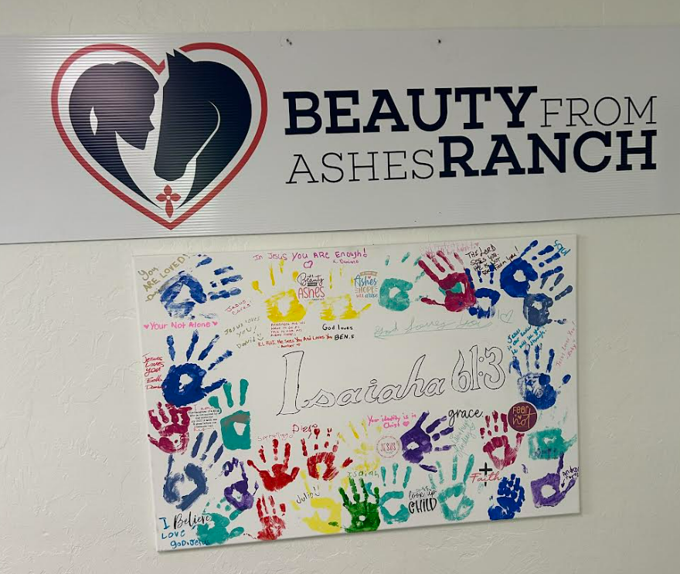

Thank you all for your continued support and dedication to Beauty From Ashes Ranch. We appreciate each one of you more than we can possibly articulate.
God Bless you all!
John George
Executive Director
Beauty From Ashes Ranch
john@beautyfromashesranch.org
info@beautyfromashesranch.org

